Lab 16: Functions for Program Organization

Roster: ____________________ and ___________________

Task 1: Tossing a Pair of Dice:
In this lab we are going to concentrate on dividing a project into reasonable pieces, passing
the results of one function to another, and using loops to shorten our code whenever possible.

The problem is to simulate the toss of a pair of dice, 100 times. In each case, we record the sum, a number between 2 and 12. We keep a count of how many times each number comes up. Then we display the results as a histogram.
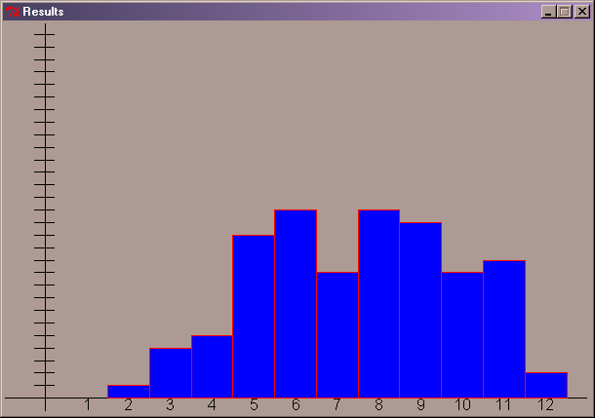

Your program should start with a preamble – a comment giving the names of the authors, and a brief description of the problem.

Next should come all the import statements you need.

Now define your functions one at a time and include a call to each function in your main(). At the very bottom should be a call to main()

The functions:
- diceRoll This function has no parameters, and returns the result of simulating the roll of two standard six-sided dice and taking the sum.
- getData This function has no parameter but it should return a list of the counts of how many times each sum appeared. It is easiest to have the item with index 2 tell you how many times a sum of 2 occurred and the item with index 3 to tell you how many times a sum of 3 occurred, etc.
  - you can initialize a list with all zeros with mylist = [0] * 13
  - Why 13? #13 because the list starts at 0 and goes to 12! I do not need the first or second indexes in the list, but it makes the coding easier later on.
  - Every time you calculate a sum, you can record that sum with the statement mylist[sum] = mylist[sum] + 1
  - (Tip: This function will *call* the diceRoll() function inside a loop.)
- setupGraphWindow This function has no parameters but it should return the window that was created. This function should
  - create and open a window of appropriate size and title
  - set the coordinates conveniently – use paper to sketch this out
  - draw the x axis
  - use a loop to draw the labels below the x axis
  - draw the y axis
  - use a loop to draw the marks on the y axis
- drawGraph This function should take the list of data produced by the first function and the window produced by the second function and draw the graph.
  - Use a loop to draw the rectangles.
  - You should be able to calculate where the lower left and upper right corner of each rectangle should be.

Save all your code in histogram.py

Task 2 : Adding More Features
Add the following features one at a time. Some of these may require changing the number of parameters to your functions
- Ask the user how many sample points he/she wants instead of assuming 100. Later you may want to alter the display function so it makes a different size y axis depending on the number of points but that is probably not necessary at this point.
- Add a function to compute the mean of the data points. The mean of course measures the average value and is given by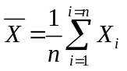 The parameter to this function will have to be the list of counts returned by the getData() function. You will know how many times you got a 2, how many times you got a 3, etc. The function should return the average.
- Add a function to display this average on the graph.

- Add a function to compute the standard deviation of the data points. The standard deviation measures how dispersed the data is.
The standard deviation is given by 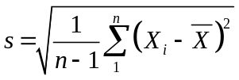 The parameters to this function will require the data points as well as the mean
- Add the function that would display this on the window.

Everyone should finish Task 1. Submit the final version of your histogram program with whatever extra enhancements you were able to complete.

ALSO, do something on the Q&A!!!

